|  |  |
| --- | --- |
| **Master Naturalist information** | ID:  Password:  URL: http://txmn.org/tmn-vms-users/ |
|  |  |

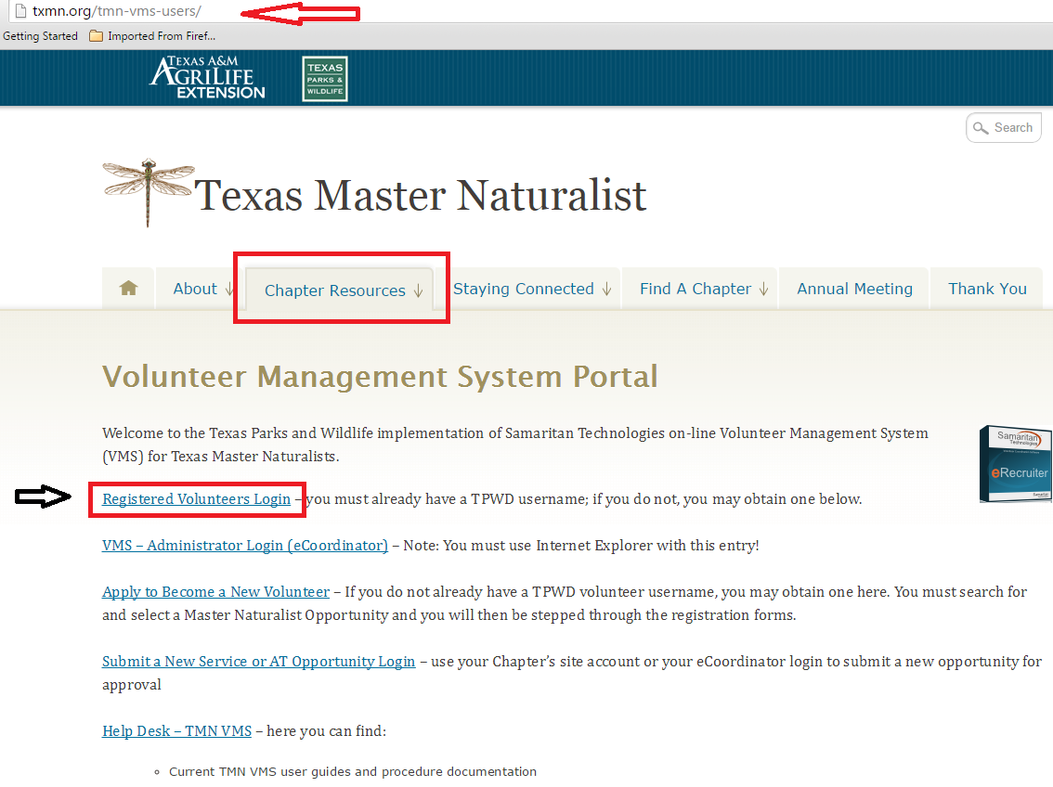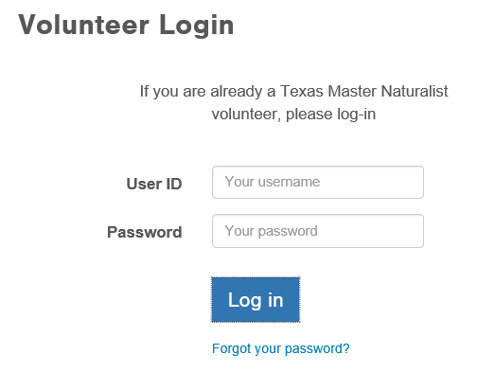

Login

Volunteer Dashboard

View your reported Hours

Opportunities that you have been approved for.

Manage your drop-down box

Add your Hours Here

You have 45 days to enter your hours

Volunteer

TPWD Hours, Not TMN Hours

Edit your information

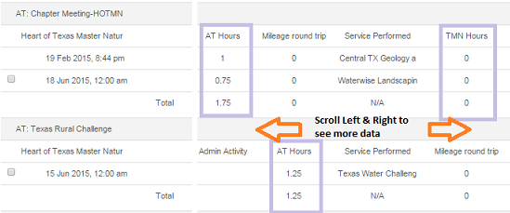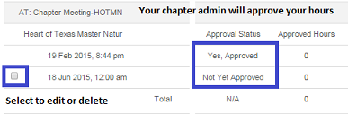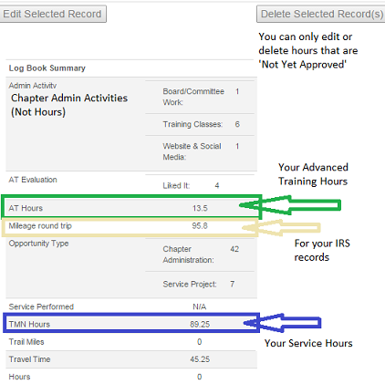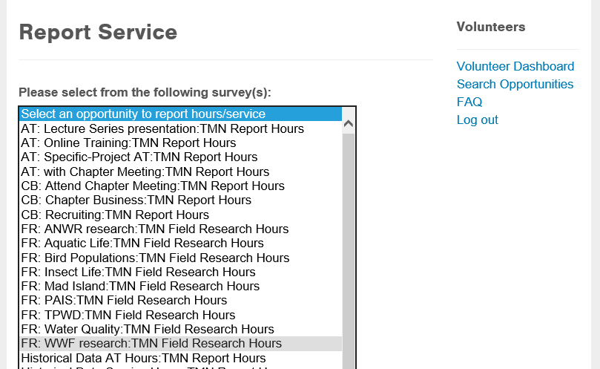

Select an Opportunity to report your hours. Fill out the survey and submit.

Events will only show up on the drop down box if you’ve been approved for them

Using Your Logbook

Reporting your Hours

My Placements

to remove an opportunity from your drop down box

Select **Remove Me** to remove an opportunity from your **Report My Service** dropdown list.

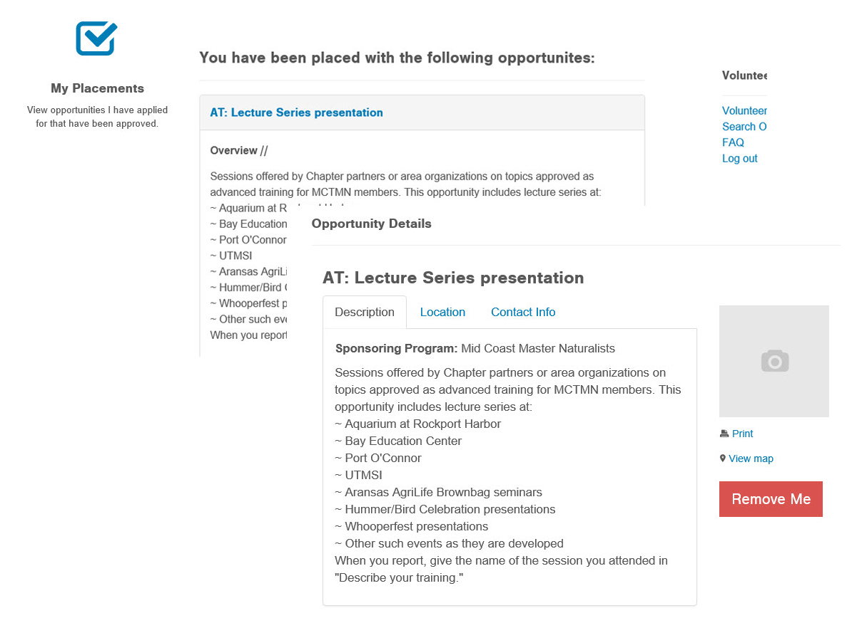

Edit My Profile

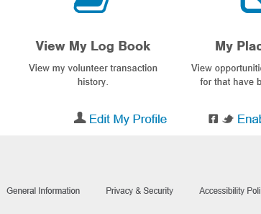

Select **Edit My Profile** to update your personal information.